**Project name:**

**Migrating from on-premises to cloud**

Keywords

* **Onprem**

**The servers which are managed by our self are called prem**

* **Microservices are managed by Kubernetes**

**Migration planning and approach**

* **ASSESSMENT**
* **MOBILIZE**
* **MIGRATE**

**MIGRATION PRACTICAL :**

* **ARCHITECTURE Discussion and understanding**
* **Architecture deployment using cloud formation**
* **Reshot or re-platform approach discussion from on-prem and azure to cloud**
* **Application discovery practical**
* **Migrating the workload using aws application migration service**
* **Database migrating using AWS database migration service**

**Assessment phase :**

* **We will use different tools to assess the current infrastructure**

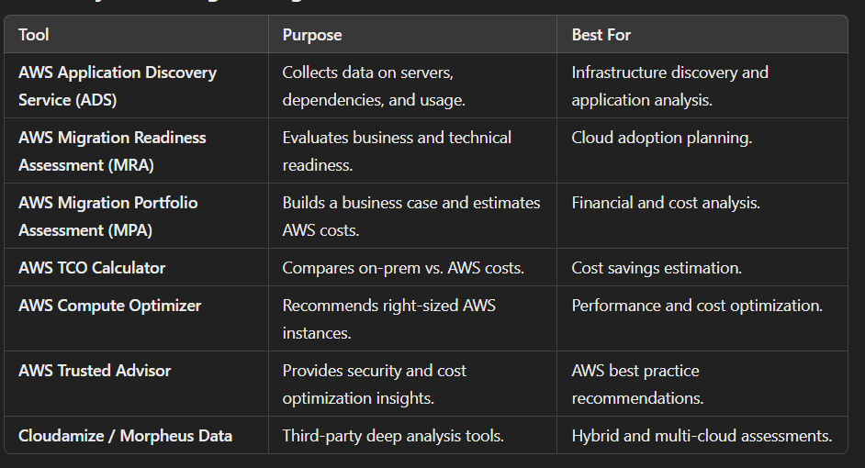

**Steps in the Assess Phase (Simplified)**

1. **Understand the Current Setup**
   * **Identify all existing servers, applications, and databases.**
   * **Gather details about infrastructure, business needs, and costs.**
2. **Use Migration Tools**
   * **Utilize tools like AWS Migration Portfolio Assessment (MPA) and AWS Application Discovery Service (ADS) to collect data.**
3. **Calculate Total Cost of Ownership (TCO)**
   * **Compare the cost of on-premises vs. AWS to build a business case for migration.**
4. **Identify Dependencies & Readiness**
   * **Find how applications connect and depend on each other.**
   * **Check if applications are ready to move to the cloud.**
5. **Prioritize Workloads for Migration**
   * **Decide which applications to migrate first (start with less critical ones).**
   * **Plan a phased approach for a smooth transition.**

**Mobilization :**

* **Discovery&planning**
* **Landing zone**
* **Skill assessment**
* **Business case**
* **Migration planning & approaching**
* **Solution operating model**

**Security and compliance**

**Migration & modernize**

* **Workload migration**
* **Operation**
* **Modernize and optimize**

**References Migration architecture**

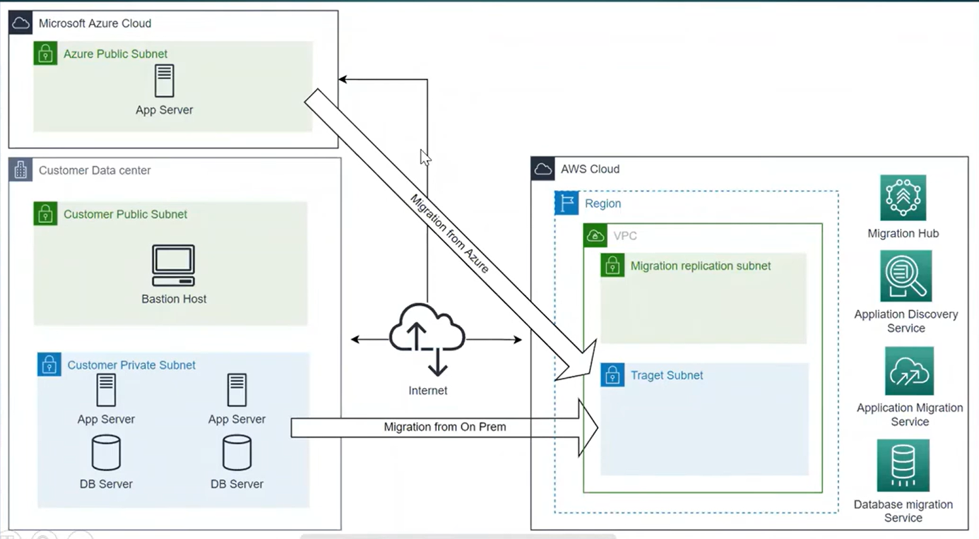

**Typical AWS Migration Architecture Diagram Components**

**1. Source Environment (On-Premises / Other Cloud)**

* Contains existing servers, applications, databases, and storage.
* Network connections (VPN/Direct Connect) link it to AWS.

**2. AWS Migration Services**

* AWS Application Discovery Service (ADS) – Identifies dependencies and collects system data.
* AWS Migration Hub – Centralized dashboard to track the migration.
* AWS Application Migration Service (MGN) – Automates Lift-and-Shift (Rehosting) migration.
* AWS Database Migration Service (DMS) – Moves databases with minimal downtime.

**3. AWS Landing Zone (Target Environment on AWS)**

* VPC (Virtual Private Cloud) – Secure networking setup.
* EC2 (Elastic Compute Cloud) – Cloud-based virtual machines replacing on-prem servers.
* RDS (Relational Database Service) – Managed database services for modernized applications.
* S3 (Simple Storage Service) – Storage for backups, logs, or migrated data.

**4. Migration Process**

* Step 1: Assessment – Discover and analyze the source environment.
* Step 2: Mobilization – Plan the landing zone and migration approach.
* Step 3: Migration Execution – Use AWS tools (MGN, DMS) to move workloads.
* Step 4: Modernization – Optimize and migrate to cloud-native services.

**How It Works in a Diagram**

**A migration architecture diagram typically shows:  
✅ Source (On-prem, Azure, or other cloud) on the left  
✅ Migration tools and services in the middle  
✅ AWS Cloud (Landing Zone, Target Resources) on the right**

**Migration references architecture**

* **Deploy the architecture using aws cloud formation stack**
* **Asscess the application using bastion host**
* **Explore the environment**

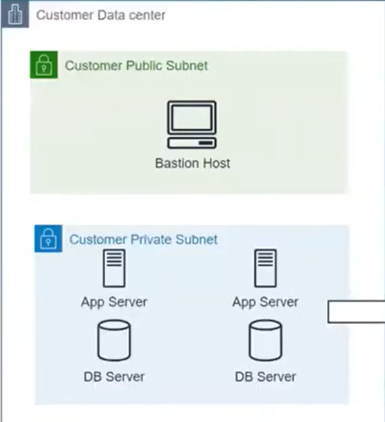

* **A Bastion Host is a secure server used to access instances in a private subnet.**
* **If an application is deployed in a private subnet, it cannot be accessed directly from the internet.**
* **To enable secure access, a Bastion Host is placed in the public subnet.**
* **Users connect to the Bastion Host via SSH or RDP, and from there, they can access private instances.**
* **The Bastion Host can log all IP addresses that access private instances, enhancing security and monitoring.**

**Let me know if you need any further modifications!**

**Step 1**

**Exploring data in AWS Athena**

AWS Athena helps in cloud migration by allowing you to analyze and check data before, during, and after migration. Since it is serverless and uses SQL queries to read data stored in Amazon S3, you can explore large datasets quickly and cost-effectively without setting up databases or servers.

* Obtain IP addresses and hostnames for servers
* Identify servers with or without agents
* Analyse system performance data for services with agents
* Track outbound communication between servers based on port numbers
* Track inbound communication b/t servers based on port numbers
* Identify running software from port numbers

Workload migration

* How to re-host your workloads
* How to re-host your workload to aws as ec2 instances
* Application migration services

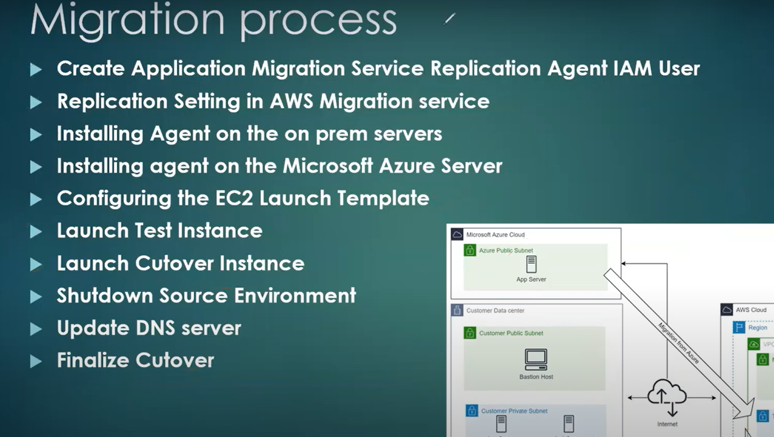

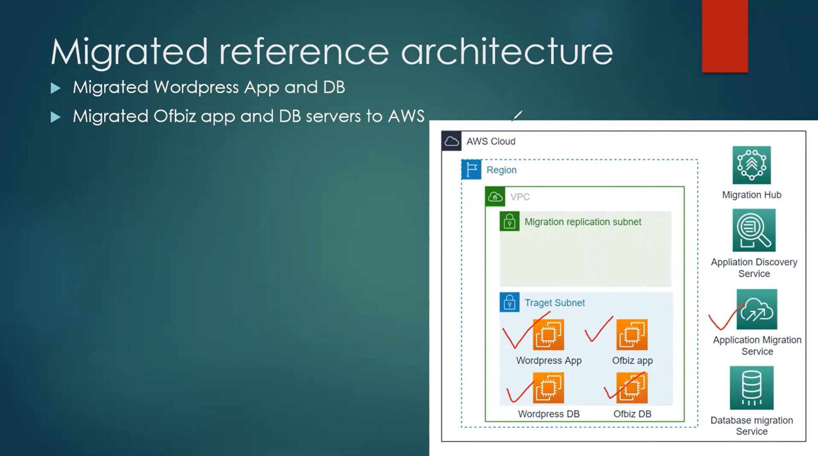

Data base migration

